Enhance PE Task Force - June 2013

Events, News and Resource Update

Events
July 10-12, 2013
Professional Development Opportunity: PE Tech Camp at Illinois State University

Dr. Dale Brown, Professor and Director of the Exercise Physiology Laboratory, will lead an upcoming Technology Workshop for Physical Education Teachers on July 10-12. Topics include the documentation of student biometrics, measurement of MVPA, development of the relationship between PE & academic performance and PE's role in enhanced cognitive function. Email dbrown@ilstu.edu or call (309) 438-7547 to reserve your spot!

Hands on activities include the latest in activity monitoring, heart rate tracking, and physical fitness assessments combined with electronic data record management. Professional presentations will include:
- Learning Readiness Physical Education – Presenter: Paul Zientarski
- PEP Grants – How to survive the process and what is needed. Presenter: Dan Phelps
- PE waivers and threats to the state PE mandate. Presenter: Mark E. Peysakhovich
- Health and Disease Trends in America: Role of the PE Teacher. Presenter: Jeff Sunderlin
- Making Movement Functional – Teaching Life Long Movement Patterns. Presenter: Chris Warren
- Powered by Polar – Latest Technological Innovations for Enhancing PE. Presenter: Jeff Gagstetter

July 16, 2013, 10-11am Webinar
Enhanced P.E.: Making the Connection Between Physical Activity, Learning, Behavior & Health
During this webinar, participants will hear from members of the Enhance P.E. Taskforce, including the State Superintendent of Education and representatives from the Illinois Association of School Administrators, the Illinois Principals Association, and IAHPERD, and a keynote address will be provided by a leading physical education coordinator around the neuroscience that supports the RETURN ON INVESTMENT of enhancing P.E. in schools. This webinar is intended for superintendents, principals, school board members, and other school officials looking to improve student health and academic achievement. Click here to register or visit www.iphionline.org

In the News
American Heart Association Praises New IOM Report on Physical Education (American Heart Association, May 23, 2013) The AHA voices its support for the findings in the IOM report and the re-introduction of the Fit Kids Act in Congress, which would strengthen physical education programs throughout the country by providing grants to schools across the country to implement physical education programs. The bill would also require educational agencies to monitor and report on the amount of time students spend engaging in physical activity and education compared to national standards endorsed by the Centers for Disease Control and Prevention.

Maximizing time in PE class (Chicago Tribune, May 17, 2013)

Dr. Hasbrouck and State Superintendent Koch pen a Letter to the Editor voicing their support for investing in quality P.E.

Exercise and Academic Performance (New York Times, Editorial Board, May 24, 2013)
The New York Times Editorial Board supports the findings in the IOM report and advocates PE “be made a core educational concern, not a dispensable option”.

The P.E. Shift (Scholastic, Spring 2013)

Phys ed programs are getting away from team sports—with great physical and academic results

Kids need to step up physical activity, report says (USA Today, March 8, 2013)
Children and teens should be more active in PE, the classroom and after-school programs.

Getting a Brain Boost Through Exercise (New York Times, April 10, 2013)
Two new experiments, one involving people and the other animals, suggest that regular exercise can substantially improve memory, although different types of exercise seem to affect the brain quite differently.

Reports and Information

Educating the Student Body: Taking Physical Activity and Physical Education to School (read online for free) Being the central place young people spend their time, schools provide ample opportunities to provide or encourage increased physical activity. The Institute of Medicine (IOM) examined the status of physical activity and PE efforts in schools, how physical activity and fitness affect health outcomes, and what can be done to help schools get students to become more active. One of its key recommendations is to make P.E. a core curriculum class. Released May 2013.

The Learning Connection: What You Need to Know to Ensure Your Kids Are Healthy and Ready to Learn Healthy children are better learners. Yet, one-third of our kids are overweight or obese, putting them at risk for a variety of health complications and chronic diseases. Fortunately, solutions to this national epidemic, along with the keys to students’ academic success, are within reach and they’re documented in Action for Healthy Kids’ new report, The Learning Connection: What You Need to Know to Ensure Your Kids Are Healthy and Ready to Learn.
The Wellness Impact: Enhancing Academic Success Through Healthy School Environments
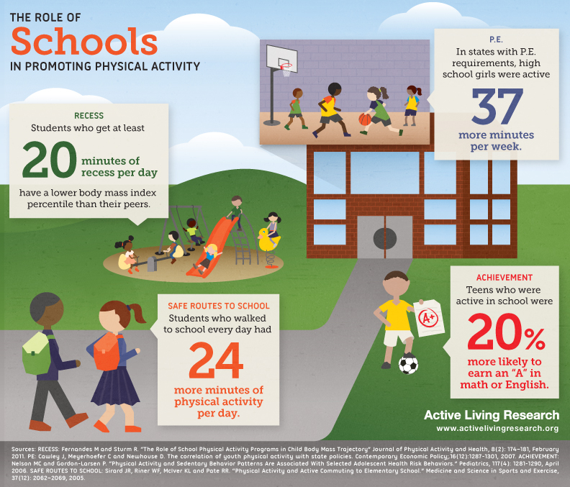
This recent report also reinforces the “learning connection” — the crucial link between quality nutrition, physical activity and academic performance. “Brain imaging shows that children experience improved cognitive function and higher academic achievement after just 20 minutes of physical activity,” said Dr. Charles Hillman of the University of Illinois at Urbana-Champaign. “Combining the many benefits of physical activity with good nutrition habits that support healthy weight can have a powerful impact on a child’s potential to learn.”

Other findings suggest:
- More than half (62%) of all teens say they do not eat breakfast every day of the week.
- Breakfast eaters have better attention and memory than breakfast skippers.
- Three-in-four high school students aren’t active for the recommended 60 minutes each day.
- Students who were more active during school performed better on standardized tests for reading, math and spelling

INFOGRAPHIC: The Role of Schools in Promoting Physical Activity
This infographic highlights a few ways that schools can promote daily physical activity for kids. Comprehensive physical activity programs that offer PE, recess, and safe and active ways to get to schools not only offer children the skills to learn how to be physically active for a lifetime, but also provide physical and mental benefits which help them perform better in school.

New Study: Brain Power from P.E.

A recent study in Illinois showed that students who were aerobically fit were 2-4 more times likely to pass their reading and math sections of the ISAT than students who were not fit.

Fitness Linked to Higher ISAT Scores
This recent study shows that aerobic capacity positively affects the academic achievement of middle school students. The study was carried out at an Illinois public middle school and used a sample size of approximately 800 students of varied socio-economic status. The study employed a FITNESSGRAM® assessment battery, which tested the five main components of physical fitness. Academic performance was evaluated using achievement on the Illinois Standards Achievement Test (ISAT) in the areas of math and reading.

Aerobic Capacity is for A+ in Illinois Schools
The most compelling conclusion of this study was that there were specific aspects of physical activity that could be associated with the academic performance of a large group of adolescents. It was found that aerobic capacity had the strongest relationship with academic achievement, as students who were aerobically fit were 2-4 more times likely to pass their reading and math sections of the ISAT than students who were not fit.

How the Brain Gets its Fuel
Aerobic exercise, the specific type of physical activity most associated with academic performance, contributes to improved cognitive function because of physiological factors that improve attention, alertness and motivation. The increase in blood flow that occurs during physical activity can also increase brain function. Finally, fitness is positively associated with attention and brain processing speed and thus impacts academic achievement.

Now What?
This study showed that a significant relationship does exist between some domains of physical fitness and academic performance. The approach of school districts to limit resources to physical education programs in order to divert resources to academic programs may actually be counterproductive. This research emphasizes the importance of physical fitness and activity as a part of every student’s day in support of their academic careers.

Bass, Ronald, Dale Brown, et al. "Physical fitness and academic performance in middle school students." Acta Paediatrica Nurturing the Child. (2013): 1-6.

